Project Report

On

**NOTEPAD DESIGNING USING JAVA IN SWING**

Submitted as a part of in-house training

In

Bachelor of Technology

(Information Technology)



*Submitted to: Submitted by:*

**Dr. Rajesh Mehta Karan Chopra (05710403114)**

**Mrs. Priyanka Vashisht Sagar Jha (06210403114)**

**Mrs. Nidhi Malik Vivek Khandelwal (05610403114)**

Department of Information Technology

**AMITY SCHOOL OF ENGINEERING AND TECHNOLOGY**

(Affiliated to Guru Gobind Singh Indraprastha University)

(June-July, 2016)

**CERTIFICATE**

This is to certify that below listed students of B.Tech in Information Technology has successfully completed their in-house summer training report entitled “Notepad Designing Using JAVA in Swing “

S.NO NAME ENROLLMENT NUMBER

1 Karan Chopra 05710403114

2 Sagar Jha 06210403114

3 Vivek Khandelwal 05610403114

This training partially fulfills their Bachelor of Technology course requirement after the second year at the **Amity School of Engineering and Technology**, an institution affiliated to **Guru Gobind Singh Indraprastha University** , Delhi.

*Dr. Rajesh Mehta Ms. Priyanka Vashisht Ms. Nidhi Malik*

*(Asst. Professor) (Asst. Professor) (Proctor)*

*Mr. M.N Gupta*

*(Head of Department of Information Technology)*

**ACKNOWLEDGEMENT**

The satisfaction and euphoria that accompany the successful completion of the project would be incomplete without mentioning the names of the people who made it possible and whose constant guidance and encouragement crowns all efforts with our success.

We extend our gratitude to **Prof. B.P. Singh**, Senior Director, **Prof. (Dr.) Rekha Aggarwal** , Director and **Prof. M.N. Gupta**, Head of Department of IT, Amity School of Engineering and Technology for providing us with excellent infrastructure and constructive environment which laid a potentially strong foundation of our professional life.

We would like to express our profound thanks to **Dr. Rajesh Mehta, Ms. Priyanka Vashisht** and **Ms. Nidhi Malik** who guided us throughout the project like an expert caption on a ship providing us each and every detail, reference and technical help, without which it was difficult to accomplish.

We would like to thank our lab assistants **Mr. Amit Kumar** and **Mr. Nitish Kumar** for providing with peaceful and working environment in our labs throughout the training.

We also express our gratitude to our classmates who were always ready to help us with helping hands to complete the project.

*Karan Chopra Sagar Jha Vivek Khandelwal*

(05710403114) (06210403114) (05610403114)

**LIST OF FIGURES**

**Figures Name Page no**

Figure 1 Sample Screen ------------------------------------------ 13

Figure 2 GANTT Chart ------------------------------------------- 15

Figure 3 ER Diagram --------------------------------------------16

Figure 4 PERT Chart ---------------------------------------------17

Figure 5 Output screen --------------------------------------------26-29

**TABLE OF CONTENTS**

Certificate------------------------------------------------------------------------------------------ 2

Acknowledgement-------------------------------------------------------------------------------- 3

List of figures ------------------------------------------------------------------------------------- 4

Contents

1. Chapter 1

1.1 Introduction ------------------------------------------------------------------------ 7

1.2 History------------------------------------------------------------------------------- 8

1.3 Applications------------------------------------------------------------------------- 9

1.4 System Specifications-------------------------------------------------------------- 9

1.4.1 List of Software used

1.4.2 List of Hardware used

2. Chapter 2

2.1 About Software---------------------------------------------------------------------- 12

2.2 Architecture of NOTEPAD-------------------------------------------------------- 13

2.3 List of Activities and Duration----------------------------------------------------- 15

2.4 GANTT Chart------------------------------------------------------------------------ 16

2.5 ER-Diagram-------------------------------------------------------------------------- 17

2.6 PERT Chart-------------------------------------------------------------------------- 18

3. Chapter 3

3.1 Implementation---------------------------------------------------------------------- 19

3.2 Result---------------------------------------------------------------------------------- 26

4. Chapter 4

4.1 Conclusion---------------------------------------------------------------------------- 30

4.2 Limitations---------------------------------------------------------------------------- 31

4.3 Future Scope--------------------------------------------------------------------------- 32

4.4 References----------------------------------------------------------------------------- 33

**CHAPTER 1**

**1.1 INTRODUCTION**

The topic of our project is “Notepad Designing Using Java in Swing”. Notepad is a generic text editor included with all versions of Microsoft Windows that allows you to open and read plain text files. If the file contains special formatting or is not a plain text file, it will not be able to be read in Microsoft Notepad.

* How to open Windows Notepad:

1. Click Start
2. Click Programs and then Accessories
3. Click the "Notepad" icon.

## How to create a text file using notepad

Open Notepad and type your text you want in the file. Once done save the file by clicking File and then Save .When saving the file make sure the file is saved with a .txt extension.

* A basic notepad consists of several basic features for manipulating the text present in the file.

The following are are basic features present in a notepad for manipulating the data present in file.

1) File

2) Edit

3) Format

4) View

The above features are further divided into sub features which perform the function associated with them on the data stored in the .txt file.

**1.2 HISTORY**

Several versions of notepad have been created in the past years. Notepad does not require a lock on the file it opens, so it can open files already opened by other processes, users, or computers, whereas WordPad cannot.

Also, since Notepad lacks advanced formatting functionality, many people find its simple, minimalistic user interface (whose look has never changed since Windows 3.1 and whose menus were last altered in Windows XP, when "Format" and "View" replaced "Search") faster and easier to use for basic text operations. The MS-DOS Editor, especially as updated in Windows 95, where it became an MDI application, also provides many features never offered by Notepad.

There are many third-party replacements for Notepad with additional functionality, including both free software (e.g. Notepad ++ and Notepad2) and freeware (e.g. TED Notepad).

Notepad lacks many features available in other text editors, basic features such as Unix-format newlines, block-select, and MDI, and it lacks full support for line wrapping.

Notepad being a basic text editor, advanced features are also missing: syntax coloring, code folding, regular expressions, macros, support of codepages and color schemes.

The various types of notepad (text editors) are:

* Microsoft Notepad, a plain text editor included with Microsoft Windows
* Text editor, a type of software also known as "notepad"
* Notepad+, a freeware text editor for Windows developed in 1996
* Notepad++, a text editor for Windows developed in 2003
* Notepad2, an open-source text editor for Windows developed in 2004

**1.3 APPLICATIONS**

* Create simple text documents
* Multi-tasking/create/edit batch files
* Print a file
* Formatting with Page Setup and Printing in Notepad
* To print a Notepad document, you can locate the document with Explorer or My Computer. Open the file. Print file by using:

1) File/Print command from the menu bar.

2) Select Print from the shortcut menu that comes up when you right click the file.

3) Can also drag and drop to a printer shortcut.

**1.4 SYSTEM SPECIFICATIONS**

System specifications help to define the operational and performance guidelines for a system. It may outline how the system is expected to perform, and what that may include. Key specifications may include interface definitions, document design rules and functional areas.

The basic system requirement for our project are :

* 512mb RAM.
* WINDOWS 7/8/10.
* 800X600 minimum monitor resolution
* Internet connection (for installation)
* Minimum 512MB RAM recommended
* 180MB hard drive space required

**1.4.1 LIST OF SOFTWARES USED**

**1) CMD.EXE**=>

Command Prompt, also known as cmd.exe or CMD(after its executable file name), is the command-line interpreter on Windows NT, Windows CE, OS/2 and e-Com Station operating systems. It is the counterpart ofCOMMAND.COM in DOS and Windows 9x systems (where it is also called "MS-DOS Prompt"), and analogous to the Unix shells used on Unix-like systems. The initial version of Command Prompt for Windows NT was developed by Therese Stowell. Command Prompt interacts with the user through a command-line interface. In Windows, this interface is implemented through Win32 console. Command Prompt may take advantage of features available to native programs of its own platform. For example, in OS/2, it can use real pipes in command pipelines, allowing both sides of the pipeline to run concurrently. As a result, it is possible to redirect the standard error stream. (COMMAND.COM uses temporary files, and runs the two sides serially, one after the other.

We used CMD.EXE to run our code.

**2) NETBEANS=>**

Net-Beans is a software development platform written in Java. The Net-Beans Platform allows applications to be developed from a set of modular software components called *modules*. Applications based on the Net-Beans Platform, including the Net-Beans integrated development environment (IDE), can be extended by third party developers.

The Net-Beans IDE is primarily intended for development in Java, but also supports other languages, in particular PHP, C/C++ and HTML5.

Net-Beans is cross-platform and runs on Microsoft Windows, Mac OS X, Linux, Solaris and other platforms supporting a compatible JVM.

We used JAVA Net-beans for writing our code.

**3) SMART DRAW**=>

Smart Draw is a visual processor used to create flowcharts, organization charts, mind maps, project charts, and other visuals. Smart Draw is compatible only with Windows operating systems. Since version 7, it uses Microsoft’s Fluent User Interface in conjunction with automated panels specific to each type of diagram.

It integrates with Microsoft Word, Excel, PowerPoint and Microsoft Project it can export diagrams to common image formats and PDF format.

We used SMART DRAW to create GANTT chart and PERT chart for our project.

**1.4.2 LIST OF HARDWARES USED**

**1) INPUT DEVICES**

These devices are used to give input to the computer. In computing, an input device is a peripheral (piece of computer hardware equipment) used to provide data and control signals to an information processing system such as a computer or information appliance. Examples of input devices include keyboards, mouse, scanners, digital cameras and joysticks. The input devices used in out project are:-

a) MOUSE.

b) KETBOARD.

**2) OUTPUT DEVICES**

An output device is any piece of computer hardware item used to communicate the results of data processing carried out by an information processing system (such as a computer) which converts the electronically generated information into human-readable form. A display device is an output device that visually conveys text, graphics, and video information. Information shown on a display device is called soft copy because the information exists electronically and is displayed for a temporary period of time. Display devices include CRT monitors, LCD monitors and displays, gas plasma monitors, and televisions.

**CHAPTER 2**

**2.1 ABOUT SOFTWARE**

The software created by our group is a notepad naming “NOTEPAD KVS”. NOTEPAD KVS is a text editor same as normal windows notepad used to create text file. NOTEPAD KVS consists of simple notepad features like file, edit, format, print, help etc. These features are further divided into sub-features which perform the specific function on the data stored in the text file.

The file created using NOTEPAD KVS is a text file with .txt extension. The code of NOTEPAD KVS was written in java in swing. Java in swing provides extended features for writing a code in java. The java code was run with the help of CMD (command prompt).

Features of our notepad are:-

* Notepad has editing features.
* Used to create/save/open/edit file.
* Within Notepad – cut, copy, and paste text.
* Copy data to Notepad from other files.
* Copy Notepad text to other word processing text or database document.

The NOTEPAD KVS can run on either of these windows naming Microsoft windows xp/7/8/10. New features can be easily added to the notepad by adding the code in the source code.

**2.2 ARCHITECTURE OF THE NOTEPAD**

NOTEPAD KVS consists of several features like:

1) **File** -This feature of the notepad is used to initialize a file. File is further divided into sub features:

* New - used to create new file.
* Open -open a file.
* Save - save the contents of file.
* Save As - save the file as (name) at specific location.
* Exit - exit from the file.
* Close -close the file feature window.

2) **Edit**-This feature of notepad is used to manipulate the text stored in a file. Edit is further divided into sub features:

* Cut- cut the content from one place to another.
* Copy - copy the content from one place to another.
* Paste-paste the content at the place where the cursor is set.

3) **Format**- This feature is used to format the text stored in files. For Eg: changing font style or size

3) **Print**- This feature is used to print the contents of the text file.

4) **Select** - This feature is used for selecting a particular file.

5) **Help** -This feature tells us about the NOTEPAD KVS.

6) **Search**- This feature is used to search a particular word from a file. Search is further divided into sub features:

* Mark
* Mark all
* Replace
* Replace all
* Find

**SAMPLE SCREEN =>**The following is the sample screen of our notepad.

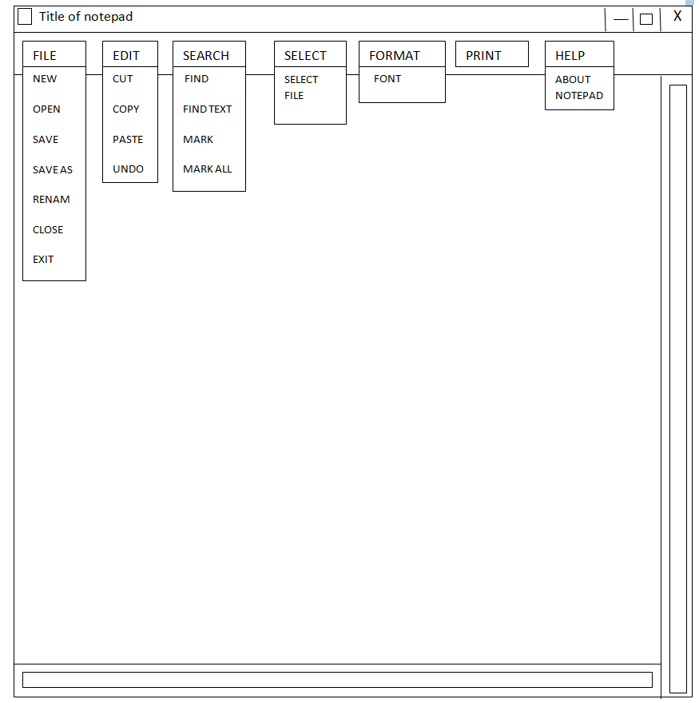

Fig1

**2.3 LIST OF ACTIVITIES AND DURATION**

|  |  |  |  |
| --- | --- | --- | --- |
| **S.NO** | **TASK** | **DAYS** | **NEXT TASK** |

|  |  |  |  |
| --- | --- | --- | --- |
| 1 | Orientation | 1 | Java application programs |
| 2 | Java application programs | 1 | Applet design |
| 3 | Applet design & project topic selection | 1 | Machine allocation |
| 4 | Software installation ,intro to GANTT & PERT chart | 1 | Er diagram |
| 5 | Er diagram | 1 |  |
| 6 | Project initialization | 1 | Screen designing |
| 7 | Screen designing | 2 | Source code logic design |
| 8 | Source code logic design | 3 | Frame designing (code) |
| 9 | Frame designing | 2 | Dimensions designing (code) |
| 10 | Dimensions designing (code) | 1 | Features designing  (code) |
| 11 | Features designing (code) | 3 | Sub features designing (code) |
| 12 | Sub features designing (code) | 3 | Final source code  (running) |
| 13 | Final source code (running) | 3 | Project review report |
| 14 | Project review report | 3 | Final presentation |

**2.4 GANTT CHART**

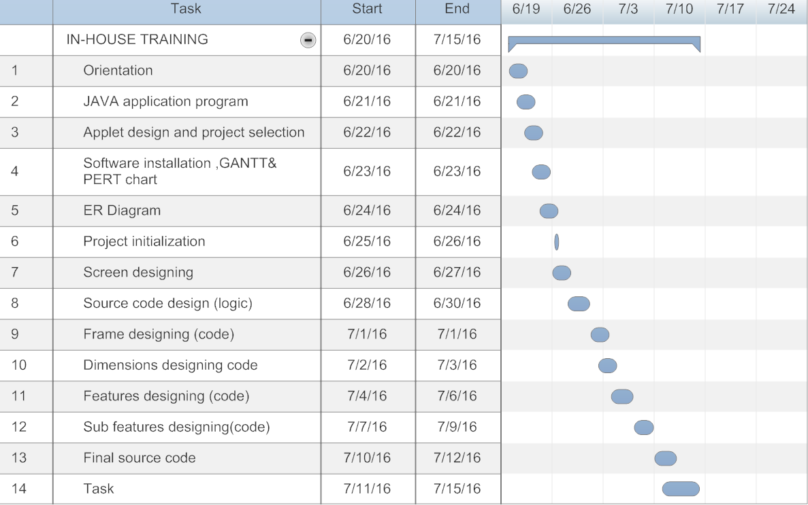

Fig 2

**2.5 ER DIAGRAM**

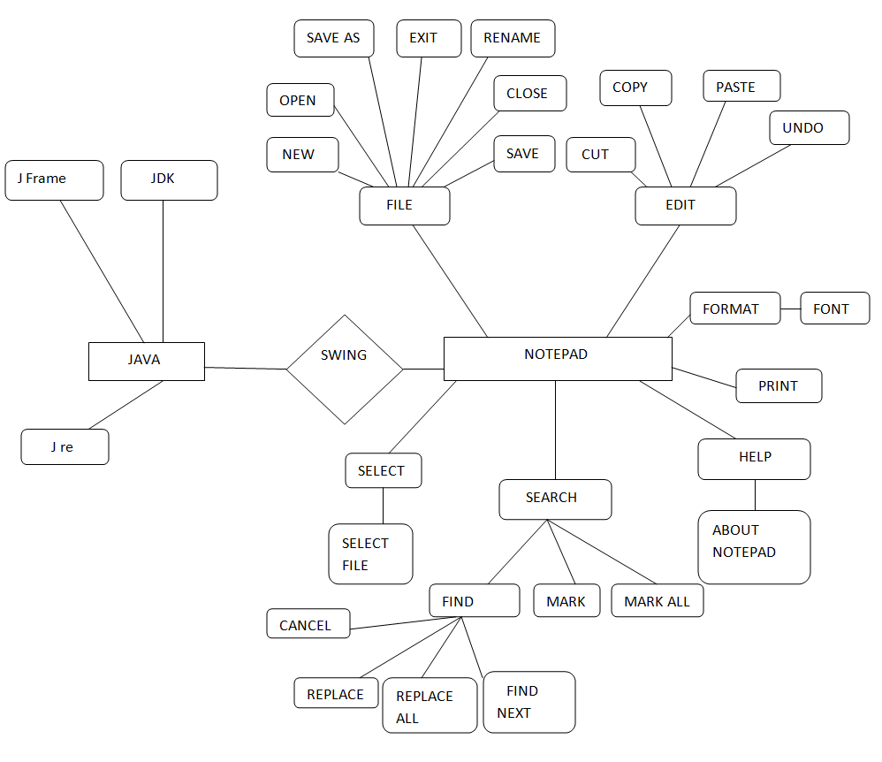

Fig 3

**2.6 PERT CHART**

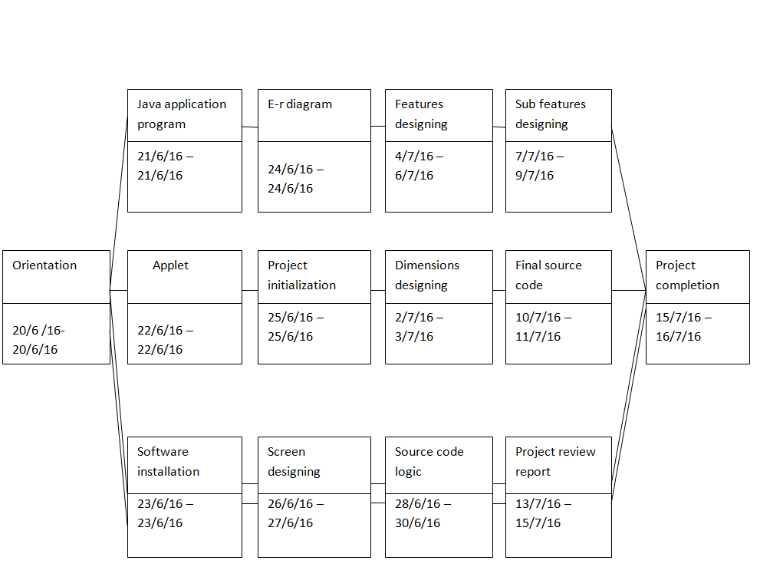

Fig 4

**CHAPTER 3**

**3.1 IMPLEMENTATION**

The following code is a part of our source code which is used for defining the screen, features and sub features.

import javax.swing.*;

import java.awt.*;

import java.awt.event.*;

import java.util.Scanner;

import java.io.*;

import javax.swing.undo.*;

import javax.swing.event.*;

class Notepad extends JFrame implements ActionListener

{

private JTextArea textArea = new JTextArea();

JButton b;

Container c;

}

private JMenuBar menuBar = new JMenuBar(); // first, create a MenuBar item

private JMenu file = new JMenu(); // defining features

private JMenu edit=new JMenu();

private JMenu search=new JMenu();

private JMenu replace=new JMenu();

private JMenu zoom=new JMenu();

private JMenu help=new JMenu();

private JMenu format=new JMenu();

private JMenu print=new JMenu();

private JMenuItem newFile = new JMenuItem(); // what's going in File? let's see...

private JMenuItem openFile = new JMenuItem(); // file menu

private JMenuItem saveFile = new JMenuItem();

private JMenuItem saveasFile=new JMenuItem();

private JMenuItem close = new JMenuItem();

private JMenuItem rename = new JMenuItem();

private JMenuItem Exit = new JMenuItem();

private JMenuItem cut =new JMenuItem(); // edit menu

private JMenuItem copy = new JMenuItem();

private JMenuItem paste = new JMenuItem();

private JMenuItem undo =new JMenuItem();

private JMenuItem find = new JMenuItem(); // format menu

private JMenuItem mark = new JMenuItem();

private JMenuItem markall = new JMenuItem();

private JMenuItem font = new JMenuItem(); // format menu

private JMenuItem selectfile = new JMenuItem(); // select menu

public Notepad()

{

textArea.setBounds(5,30,460,460);

this.setSize(500, 300); // set the initial size of the window

this.setTitle("NOTEPAD KVS"); // set the title of the window

setDefaultCloseOperation(EXIT_ON_CLOSE); // set the default close operation (exit when it gets closed)

this.textArea.setFont(new Font("Century Gothic", Font.BOLD, 12)); // set a default font for the TextArea

JScrollPane sp = new JScrollPane(textArea);

this.getContentPane().setLayout(new BorderLayout()); // the BorderLayout bit makes it fill it automatically

this.getContentPane().add(sp);

this.getContentPane().add(sp);

this.getContentPane().add(sp);

this.setJMenuBar(this.menuBar); // add our menu bar into the GUI

this.menuBar.add(this.file); //will add file

this.file.setLabel("FILE");

this.menuBar.add(this.edit);

this.edit.setLabel("EDIT"); // will add the edit

this.menuBar.add(this.search);

this.search.setLabel("SEARCH"); // will add search

this.menuBar.add(this.select);

this.select.setLabel("SELECT");

this.menuBar.add(this.format);

this.format.setLabel("FORMAT"); // will add format this.menuBar.add(this.print);

this.print.setLabel("PRINT"); // will add print this.menuBar.add(this.help);

his.help.setLabel("HELP"); // will add help

this.newFile.setLabel("New");

this.newFile.addActionListener(this); // new file

this.file.add(this.newFile);

this.openFile.setLabel("Open"); // open

this.openFile.addActionListener(this);

this.file.add(this.openFile);

this.saveFile.setLabel("Save"); // save file

this.saveFile.addActionListener(this);

this.file.add(this.saveFile);

this.saveasFile.setLabel("Save As"); // save as

this.file.add(this.saveasFile);

this.aboutNotepad.setLabel("About Notepad"); // about notepad

this.aboutNotepad.addActionListener(this);

this.help.add(this.aboutNotepad);

this.close.setLabel("Close"); // close

this.close.addActionListener(this);

this.file.add(this.close);

this.rename.setLabel("Rename"); // rename

this.rename.addActionListener(this);

this.file.add(this.rename);

this.exit.setLabel("Exit"); // exit

this.exit.addActionListener(this);

this.file.add(this.exit);

this.cut.setLabel("Cut"); // cut

this.cut.addActionListener(this);

this.edit.add(this.cut);

this.copy.setLabel("Copy"); // copy

this.copy.addActionListener(this);

this.edit.add(this.copy);

this.paste.setLabel("Paste"); // paste

this.paste.addActionListener(this);

this.edit.add(this.paste);

this.undo.setLabel("Undo"); //undo

this.undo.addActionListener(this);

this.edit.add(this.undo);

this.find.setLabel("Find"); // find

this.find.addActionListener(this);

this.search.add(this.find);

this.mark.setLabel("Mark"); //mark

this.mark.addActionListener(this);

this.search.add(this.mark);

this.markall.setLabel("Mark All"); //mark all

this.markall.addActionListener(this);

this.search.add(this.markall);

this.font.setLabel("Font"); // font

this.font.addActionListener(this);

this.format.add(this.font);

this.selectfile.setLabel("Select File"); // select file

this.selectfile.addActionListener(this);

this.select.add(this.selectfile);

}

**3.2 RESULT**

**SCREENSHOTS OF OUTPUT**

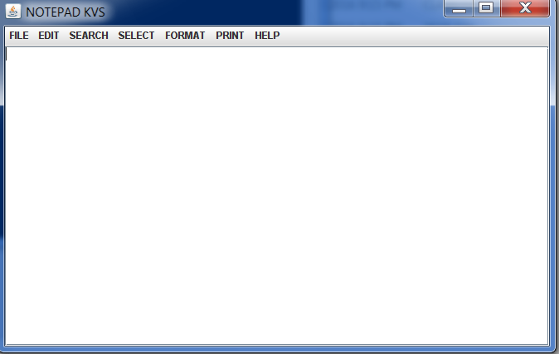

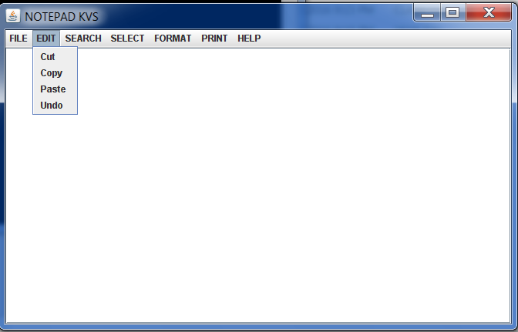

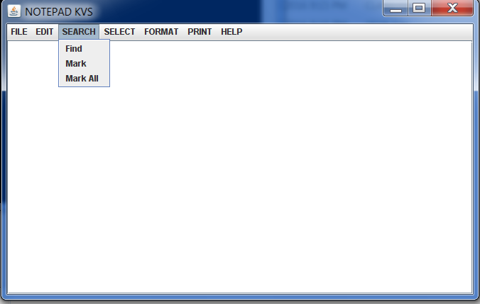

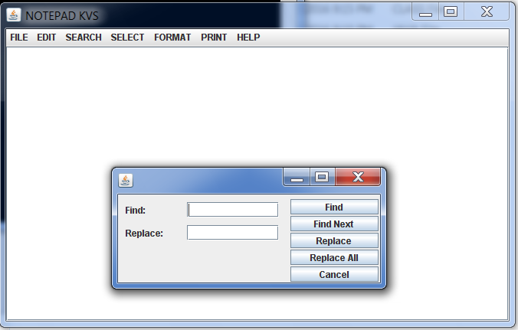

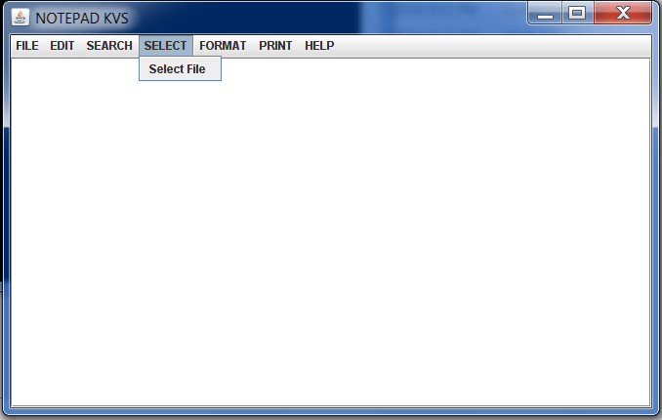

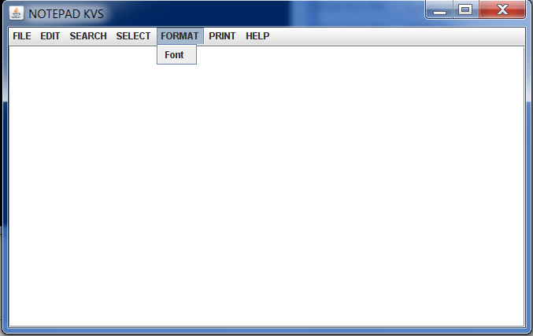

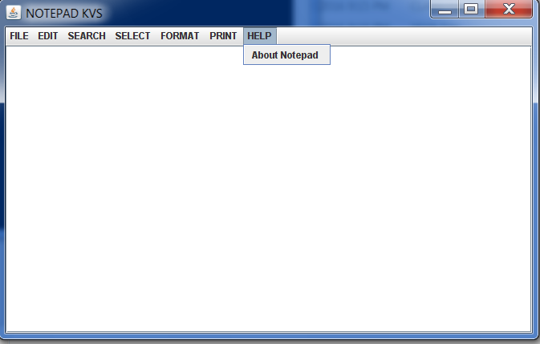

**CHAPTER 4**

**4.1 CONCLUSION**

The notepad created by our group naming “NOTEPAD KVS” consist of following features:

1) **File**: This feature is further divided into sub features as

a) New = create new file.

b) Open = open a new file.

c) Save= save a file.

d) Save as= save the file as.

e) Close = close a file.

f) Exit= exit a file

2) **Edit**: This feature is used for editing a file. This feature is further

divided into sub features as

a) Cut = cut content from a file.

b) Copy = copy the content of a file.

c) Paste = put the selected content into the file.

d) Undo = cancel the last performed step.

3) **Print**: This is used to print the file.

4) **Help**: gives the brief description about the notepad features and its sub features.

a) About notepad

5) **Search**: This is used for searching some contents in a file. This is further divided into sub features as

a) Find

b) Find text

c) Mark

d) Mark all

6) **Format**: This is used to format the contents of a file. Eg : setting font size and color.

7) **Select**: This is used for select a particular file.

a) Select file

**4.2 LIMITATIONS**

The “NOTEPAD KVS” does not have the more complex features like:

1) Zoom: a) zoom in

b) zoom out

2) Time/Date under edit section.

3) Word wrap under format section.

4) Jump up/Jump down under search section.

5) NOTEPAD KVS consists of only basic features.

6) NOTEPAD KVS can only work for .txt files.

**4.3 FUTURE SCOPE**

The “NOTEPAD KVS” can be used as a basic notepad. More features can be easily added in “NOTEPAD KVS” easily and efficiently.

* NOTEPAD a simple text editor, using JAVA GUI components which will reflect the platform independence, robustness and ease of development of JAVA SE in a simple application.
* Creating and Saving Documents
* Editing Documents
* Formatting Text  
  Other Features Proposed System Features Creating and Saving Documents New File  
  Save File,Open File,Exit Editor Editing Documents Undo and Redo,Cut, Copy, Paste,Select All
* Find and Replace Formatting Text Font Style Size Other Features Word Wrap Shortcuts Date & Time Technological Components

•Swing-Package  
•AWT-Package  
•Util-Package  
•Text Package and Swing Package

* JDialog, JFileChooser, JMenuBar,JMenu,JMenuItem ,JScrollBar  
  JScrollPane, JTextArea ,AWT Package, AWT EVENT ,ClipBoard Font Util Calendar Scanner Text Simple Date Format Conclusion Notepad is a common text-only editor.
* Simple text editors like Notepad may be used to edit text with mark-up,such as HTML.However, because they lack many features (such as syntax highlighting), web developers may favour more specialized editors for this purpose. Easier to use for basic text operations.

**4.4 REFERENCES**

* Suraj Pandey, LinlinWu1, Siddeswara Mayura Guru, Rajkumar Buyya, “Java swings in *Computing Environments*”, CSIRO, 2013.
* M. Armbrust, A. Fox, R. Grifth, A. D. Joseph, R. Katz, A. Konwinski, G. Lee, D. Patterson, A. Rabkin, I. Stoica, and M. Zaharia, “*Above the clouds A berkeley view of java swings*” Technical report, University of California at Berkeley, February 2012.
* R. Buyya, S. Pandey, and C. Vecchiola,”*Java swing toolkit for market-oriented computing*”, Volume 5931 of LNCS, pages 24–44. Springer, Germany, December 2010.
* S. Pandey, W. Voorsluys, M. Rahman, R. Buyya, J. Dobson, and K. Chiu,”*A notepad environment for distributed systems*” ,Concurrency and Computation: Practice & Experience, 21(16):2118–2139*,* November 2010.